# 

Console UI- class diagram

Menu contains a garage object

Program class – Runs the program.

Menu class – Navigate the user choices in the program.

Enum eGarageOption – contain the services given by the garage.

IO class - in charge of making interaction with the user by printing and messages and getting input.

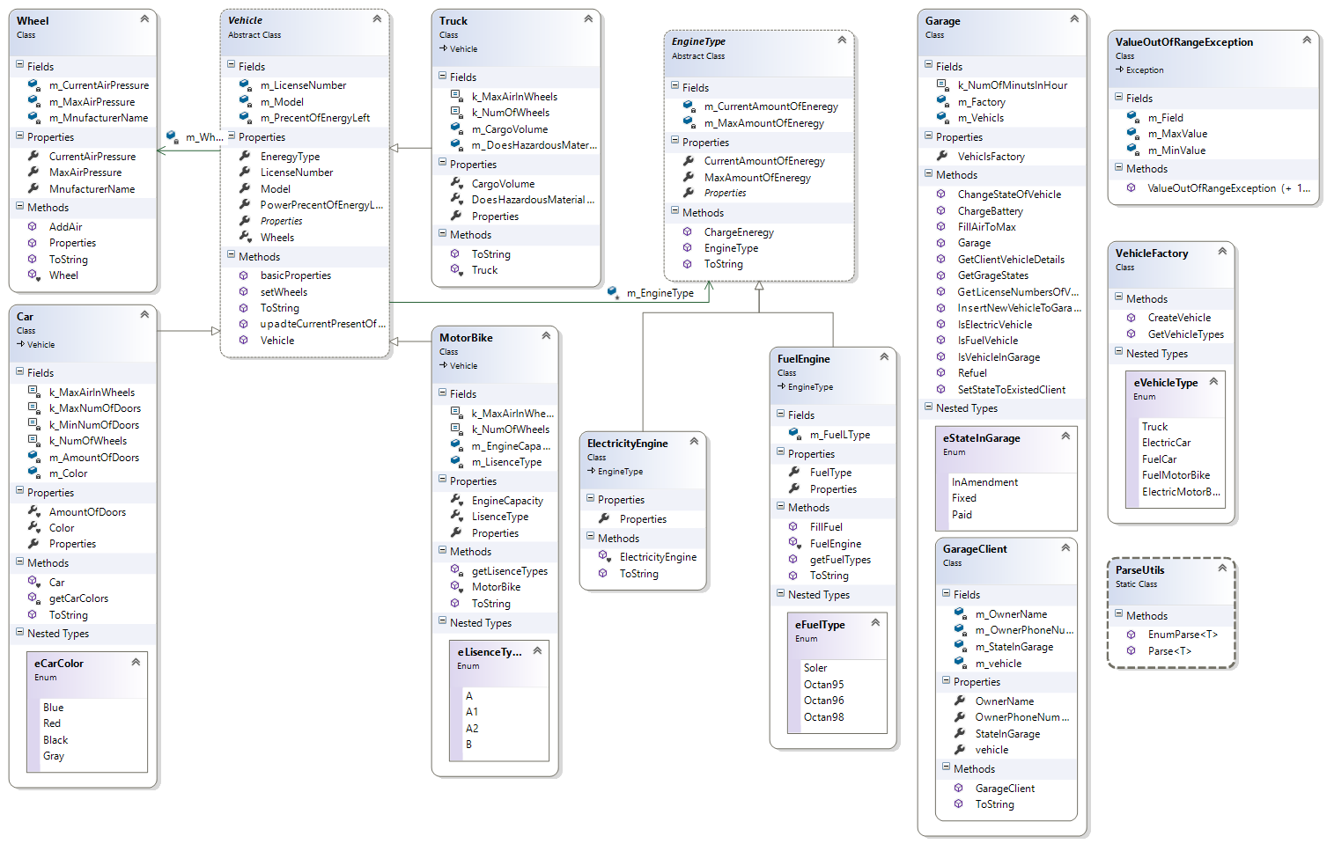jkl;kl;hj

Garage logic - class diagram

abstract class for all kind of vehicle. Vehicle class –

Car class – kind of vehicle

Enum eColor – holds all the color options for car.

Truck class – kind of vehicle

MotorBike class - kind of vehicle

Enum eLIcenseType - holds all the license type options for motorbike.

EngineType class – abstract class for electric engine and fuel engine.

FuelEngine class – kind of engine

Enum eFuelType - holds all the fuel type options for fuel engine.

ElectricEngine class – kind of engine

Garage class – manage all the services given and

ValueOutOfRange class – in charge of give exeptions of errors occurred because of out of range values.

VehicleFactory class – in charge of building new cars.

Parse utils class – in charge of checking parse between different kind of variables types.

First student details: 312587959 – Asaf Zalcman.

Second student details: 206199192 – Omri Cohen.